#load Data Airpassenger

data("AirPassengers")

#finding the class name

class(AirPassengers)

#Data In time series format

#start of time series

start(AirPassengers)

#Exp:05

#start of time series

end(AirPassengers)

frequency(AirPassengers)

#The cycle of this time series is 12 month in a year

summary(AirPassengers)

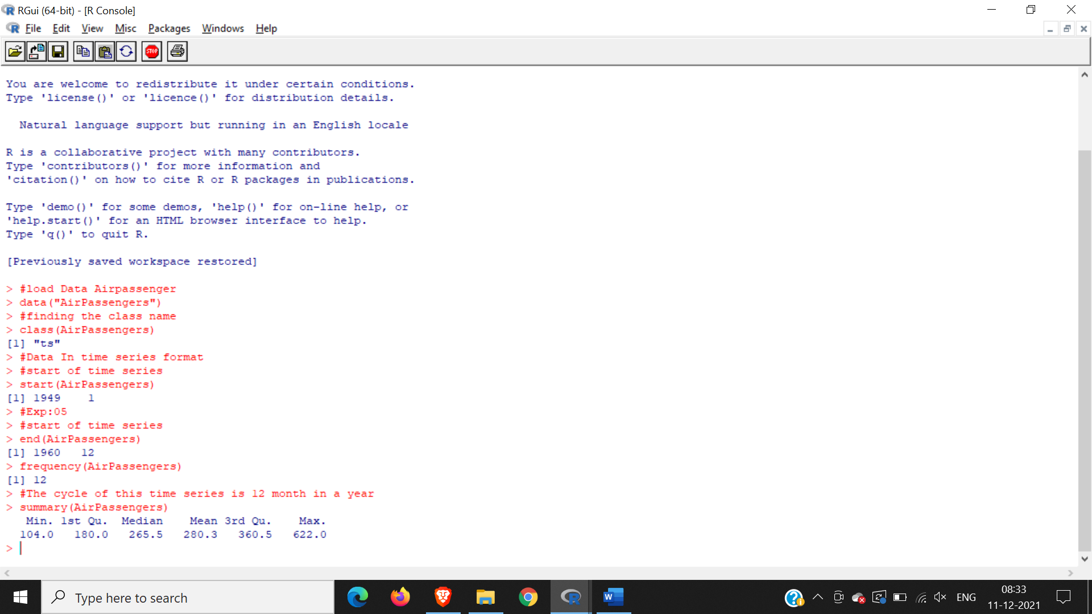

#the number of passenger are distributed across the spectrum

plot(AirPassengers)

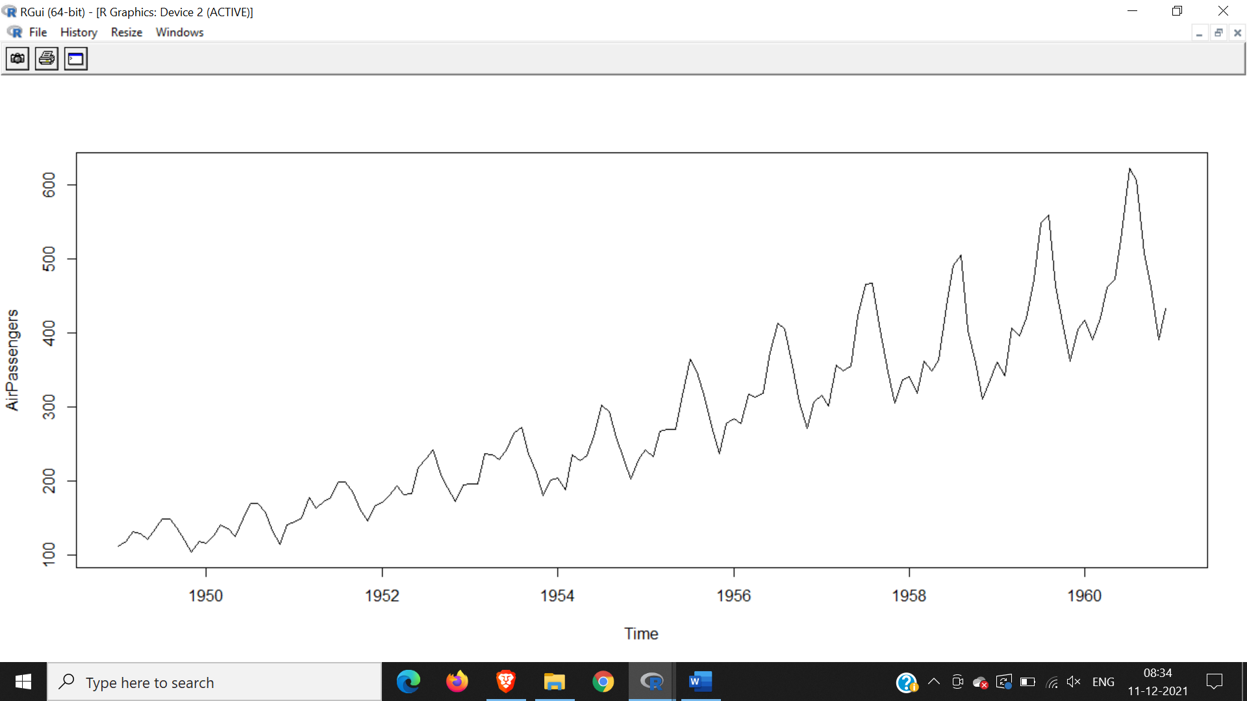

#this will plot the time series

abline(reg=lm(AirPassengers~time(AirPassengers)))

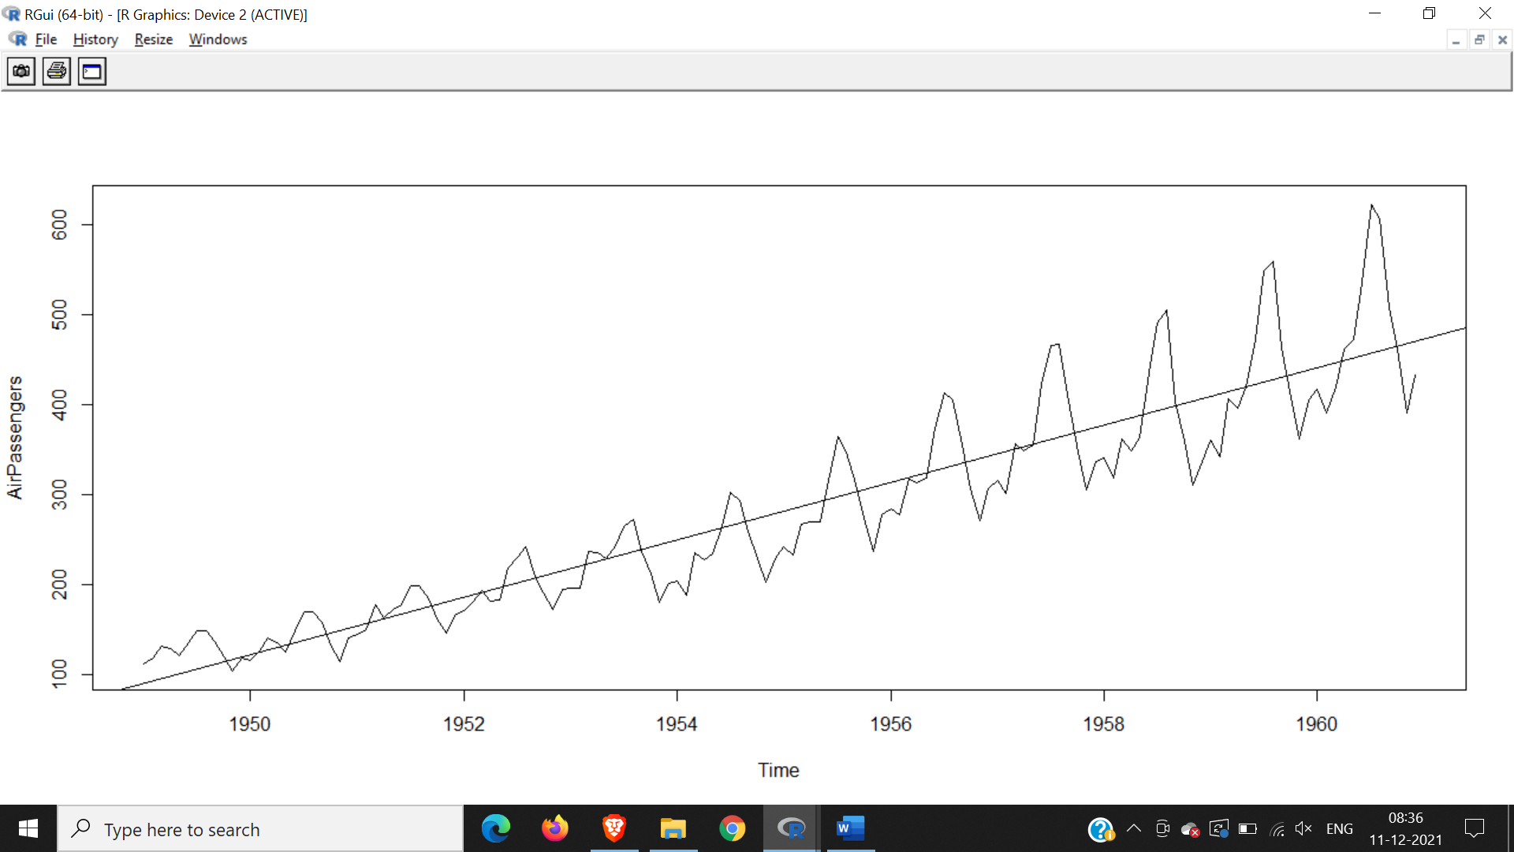

#This will print the cycle across years

cycle(AirPassengers)

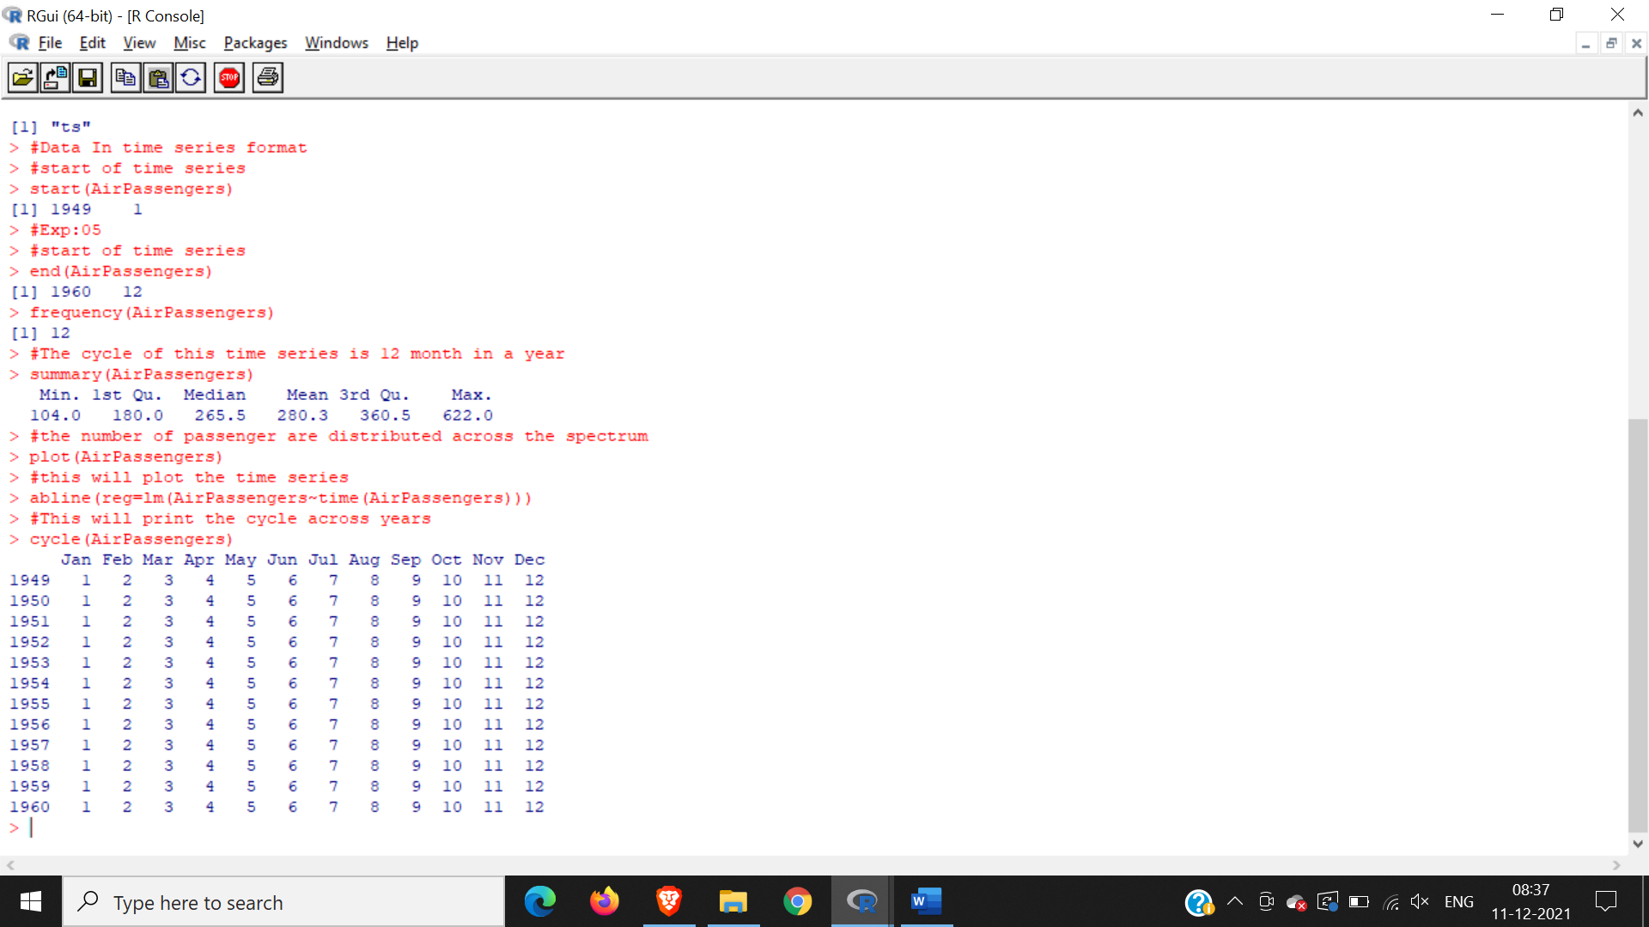

#this wil aggreate the cycles and display a year on year trend

plot(aggregate(AirPassengers,FUN=mean))

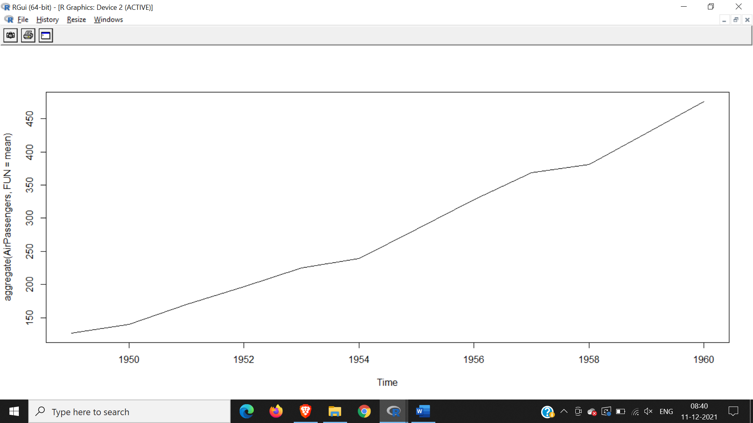

#box plot across month will give us a sense on seasonal effect

boxplot(AirPassengers~cycle(AirPassengers))

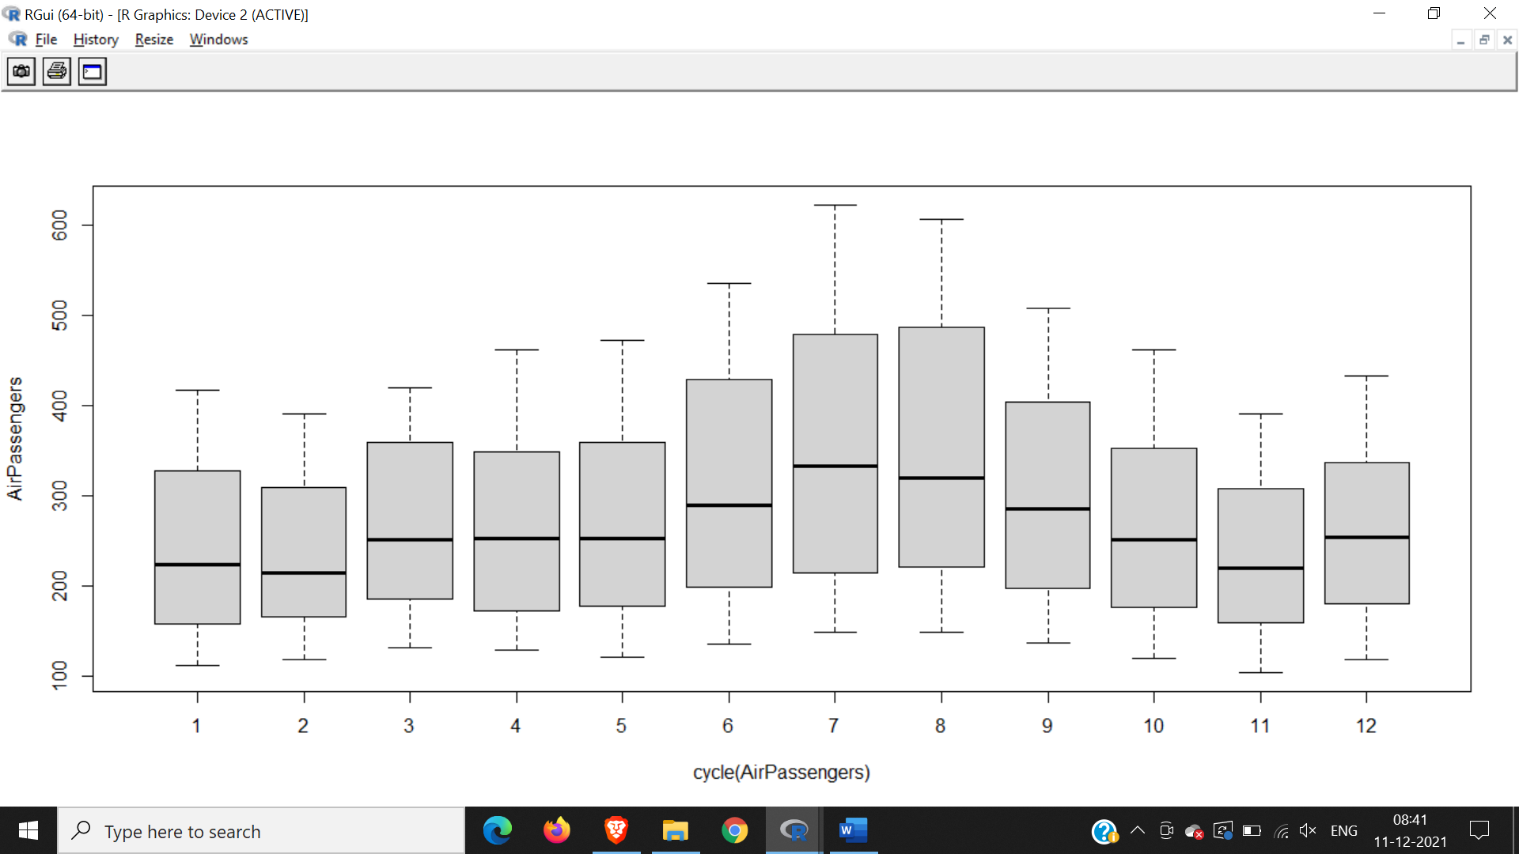

acf(log(AirPassengers))

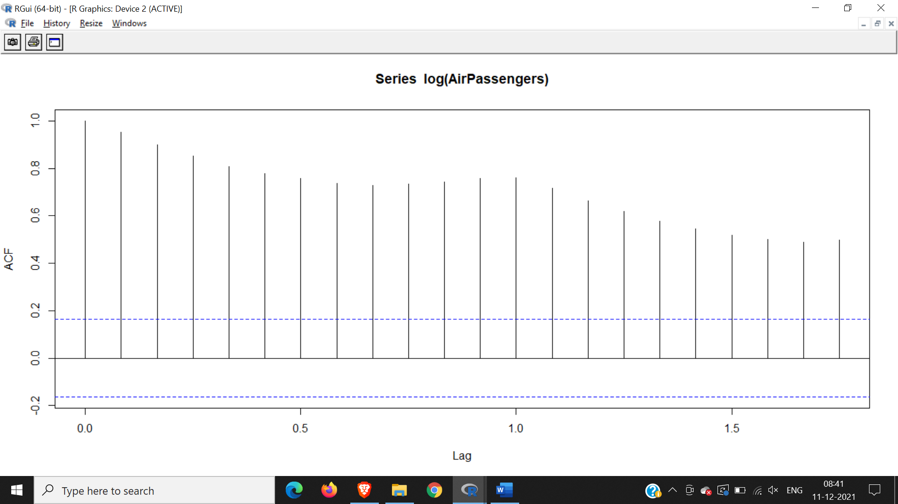

acf(diff(log(AirPassengers)))

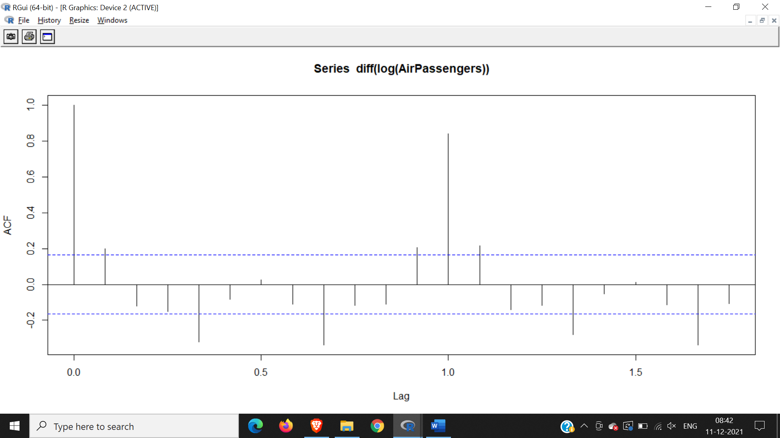

(fit <- arima (log(AirPassengers), c(0, 1, 1), seasonal = list (order= c(0, 1,1),period=12)))

pred <- predict(fit, n.ahead = 10\*12)

ts.plot(AirPassengera,2.718^pred$pred,log="y",lty=c(1,3))

